BT Database User Guide

**Introduction**

Welcome to the BT Database Version 0.1, which aims to be a flexible database with different user levels so that employees and managers can work together and manage data efficiently.

*Note:*  
When first loading the system if you are presented with the following message in access:



You must close the login form, click the Options button and enable the restricted content before continuing.

**Logging in**

Managers will be supplied with the correct login information directly from the development team before the system is activated. Employees should consult the Human Resources or Management department for issues regarding login information.

To login you must enter your first and last name in the “Employee Name” field and then your password in the “Password” field and finally click the “Employee Login” button to finish the process. If you have entered your correct account information you will now be authorized and you will continue onto the correct switchboard defined by your employee role.

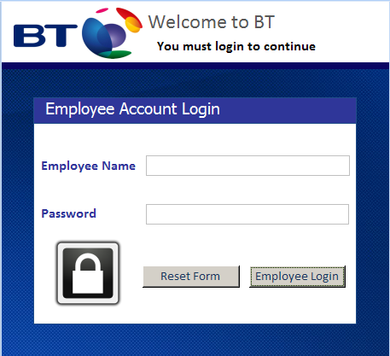

**Management Switchboard**

Managers have full control over the database and can view all information. Managers are listed as database developers.

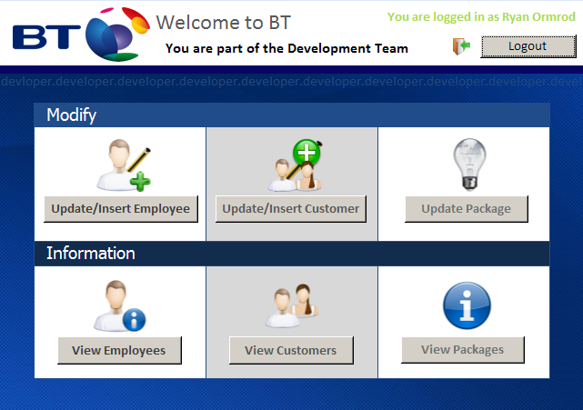

**Human Resources Switchboard**

Human resources are limited to employees and can only access employee information.